1. Create view vw_updatable_products (use same query whatever I used in the training)

Try updating view with below query and see if the product table also gets updated.

Update query:

UPDATE updatable_products SET unit_price = unit_price * 1.1 WHERE units_in_stock < 10;

create view update_products_view as

select product_id,product_name,unit_price,units_in_stock

from products where discontinued =0;

UPDATE update_products_view SET unit_price = unit_price * 1.1

where units_in_stock < 10;

select * from update_products_view where units_in_stock < 10;

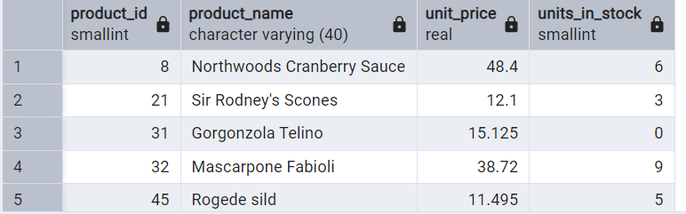

Begin;

update products

set unit_price=unit_price*1.1 where category_id=1;

select product_id,product_name,unit_price,

units_in_stock from products where category_id=1;

Commit;

select * from products where category_id=1;

end;

Rollback;

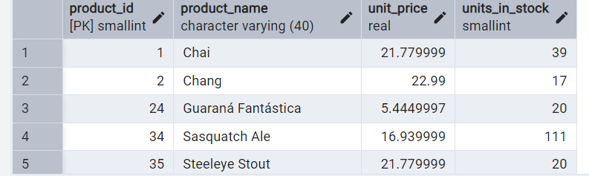

select * from products where category_id=1;

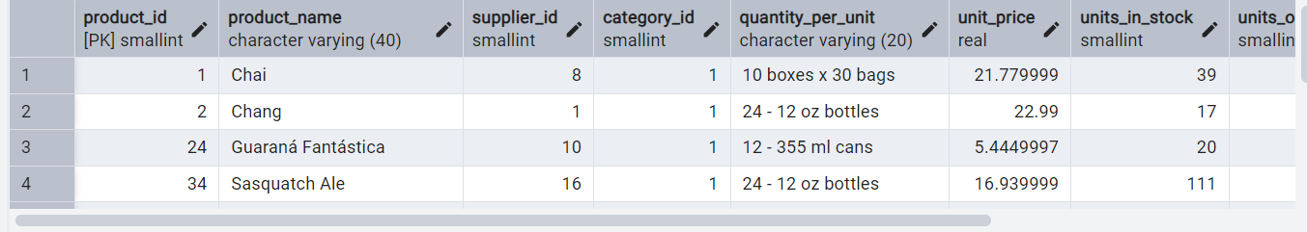

2.     Transaction:

Update the product price for products by 10% in category id=1

Try COMMIT and ROLLBACK and observe what happens.

Begin;

update products

set unit_price=unit_price*1.1

where category_id=1;

select product_id,product_name,unit_price,

units_in_stock from products where category_id=1;

Commit;

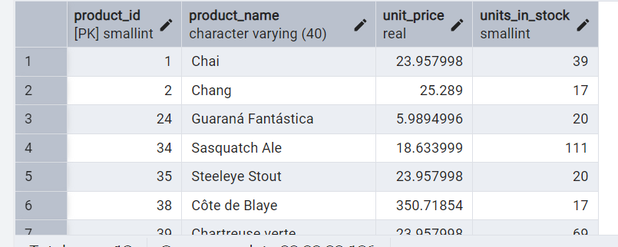

select * from products where category_id=1;

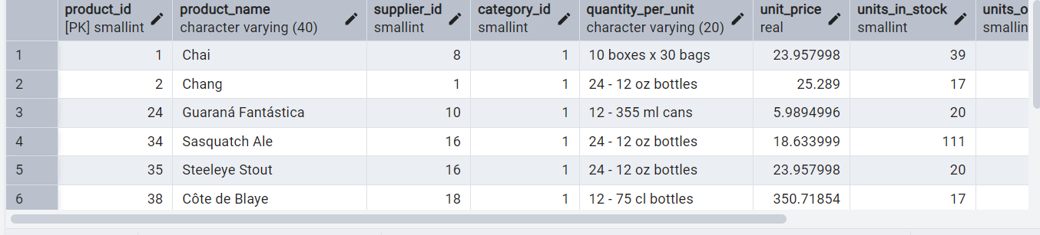

3.     Create a regular view which will have below details (Need to do joins):

Employee_id,

Employee_full_name,

Title,

Territory_id,

territory_description,

region_description

create view employee_territory_region as

select e.employee_id,

e.last_name || ' ' || e.first_name as employee_fullname,e.title,

et.territory_id,t.territory_description,r.region_id,r.region_description

from employees e

inner join employee_territories et on e.employee_id=et.employee_id

inner join territories t on et.territory_id=t.territory_id

inner join region r on r.region_id=t.region_id;

select * from employee_territory_region

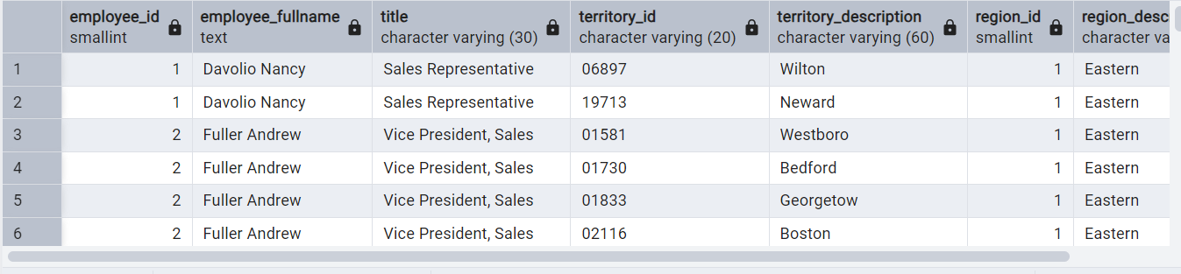

4.     Create a recursive CTE based on Employee Hierarchy

